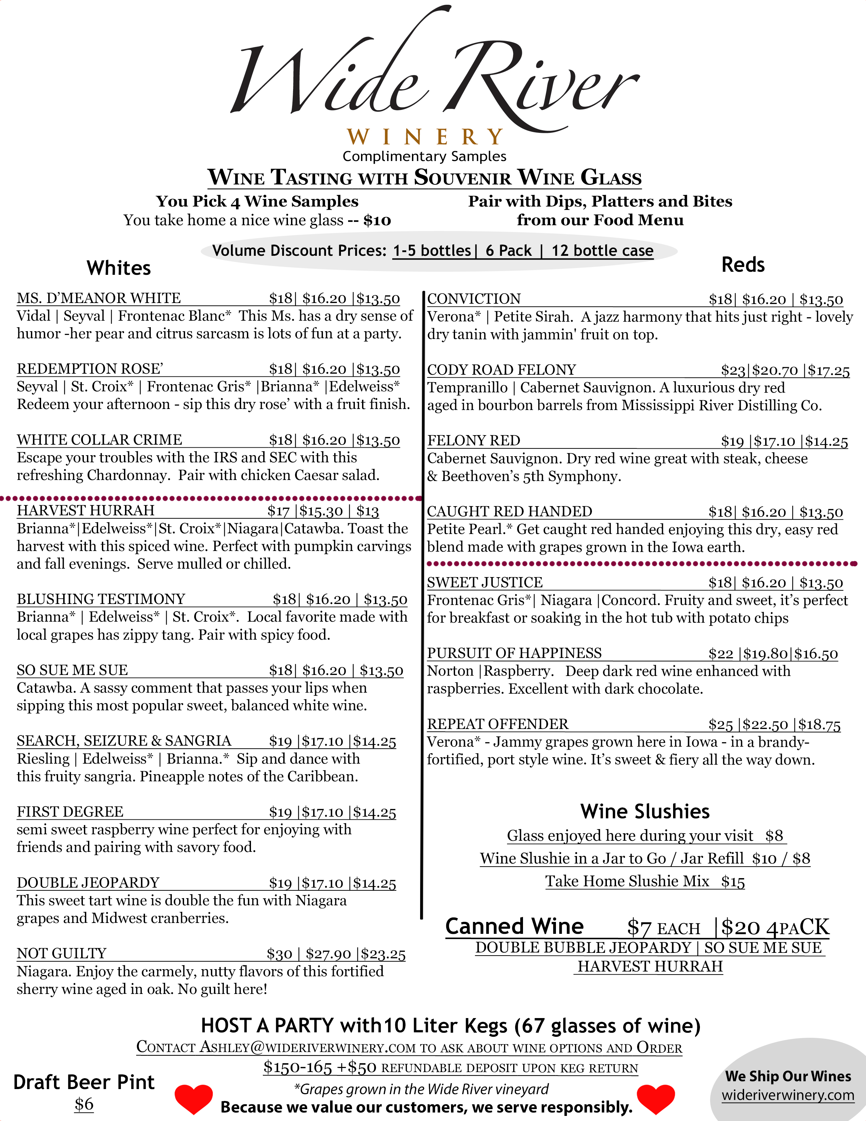
Clinton Area:  Clinton Liquor & Convenience  Clinton Lumberkings  Don’s Jewelry  Grandma’s Goody Jar  Hy-Vee  Fareway  Gateway Mart  Jewel Osco  Legends Sports Bar  Lyon’s Filling Station  Ohanas  North Bridge BP  Ray’s Time Out  Vitale’s  Walmart  Wild Rose Casino  Camanche:  Camanche Food Pride  Quad Cities Iowa:  Fareway Davenport  Fresh Thyme  High Five Lanes & Games at TBK Center  Hy-Vee Bettendorf  Hy-Vee West Locust St.  Hy-Vee E. Kimberly Rd.  Hy-Vee West Kimberly Rd.  Hy-Vee 53rd Street  State Food Mart “Easy In Easy Out” Bettendorf  Target Davenport Elmore Ave.  Wide River Winery (1128 Mound St, Davenport)  Walmart Elmore Ave.  Walmart W. Kimberly Rd.  Quad Cities Illinois:  Bally’s Hotel and Casino (formerly Jumers)  Hy-Vee Silvis  Hy-Vee Ave. of the Cities  Hy-Vee Milan  Hy-Vee Rock Island  Jewel-Osco East Moline  Jewel-Osco Moline  Jewel-Osco Silvis  Blue Grass & Buffalo:  Jeff’s Market  Burlington:  Hy-Vee Burlington Agency Road  Fareway Burlington  Cedar Rapids Area:  Hy-Vee Edgewood Road | Des Moines Area:  Wines of Iowa – Valley Junction  Dewitt:  Randy’s Market  Murphy’s Pub  Scott Drug  Pride of the Wapsi Pumpkin Patch  Dubuque/ East Dubuque:  Hy-Vee Dodge St.  Hy-Vee Locust St.  Family Beer and Liquor  Eldridge:  North Scott Foods  Eldridge Mart  Fort Madison:  Fareway  Iowa City Area:  Hy-Vee Coralville  Hy-Vee Coralville Crosspark Rd  Hy-Vee Iowa City N. Dodge St.  Le Claire:  Cody Mart  Crane & Pelican  LeClaire Grocery  Wide River Winery (106 N. Cody)  Maquoketa:  Make A Splash  KJ Convenience  Walmart Maquoketa  Mt. Pleasant:  Hy-Vee  Muscatine:  Hy-Vee 2nd Ave  Hy-Vee Wine & Spirits 6th St  Pella:  Lakefront Living  The Wijn House  Preston:  Olys Garage & Convenience  Albany, IL:  Benson’s on the Mississippi  Aledo, IL:  Mercer Market | Dixon, IL:  Liquor N’ Wine  Erie, IL :  Shaheen’s Village Market  Freeport, IL:  Freeport Cork & Keg Liquors  Fulton, IL:  Eagle River Liquor  Galesburg, IL:  Hy-Vee on Henderson  Hy-Vee East Main  Geneseo, IL:  BP Wolf Road  Fareway  Trackside Liquors  Kewanee, IL:  Sullivan’s Foods  Lanark, IL:  Lanark Foods  Morrison, IL:  Sullivan’s Foods  Oregon, IL:  Cork & Tap  Peoria, IL:  Hy-Vee – Sheridan Road  Hy-Vee – N Orange Prairie Road  Schnuck’s – Centerway Drive  Schnuck’s – University  Polo, IL:  Polo Fresh Food Market  Port Byron, IL: Daddios Liquor  Rochelle, IL  Liquor N Wine  Savanna, IL:  A.O. Elliot Wine & Brew House  Sullivan’s Foods  Sterling/Rock Falls, IL  Discount Liquors  Rusty Fox  The Beverage Store  Stockton, IL:  Coxy’s Liquor  Sullivan’s Foods  Thomson, IL: Route 84 Diner

